**Exercise 4: Building a Simple REST API with Node.js**

# Objective

In this exercise, you will learn how to build a simple REST API using Node.js, along with the ‘**http’** and ‘**fs**‘modules. The API will offer two main functionalities: reading data from a JSON file and updating data in this file.

# Requirements

* Node.js is installed on your machine.
* Basic knowledge of JavaScript.

## Exercise 1: Demo about File System Interaction – File Server

* Create folder namely node-file
* Init NodeJS project
* Install the fs module using the following command: npm i fs
* Create a file file.js and add the following code:

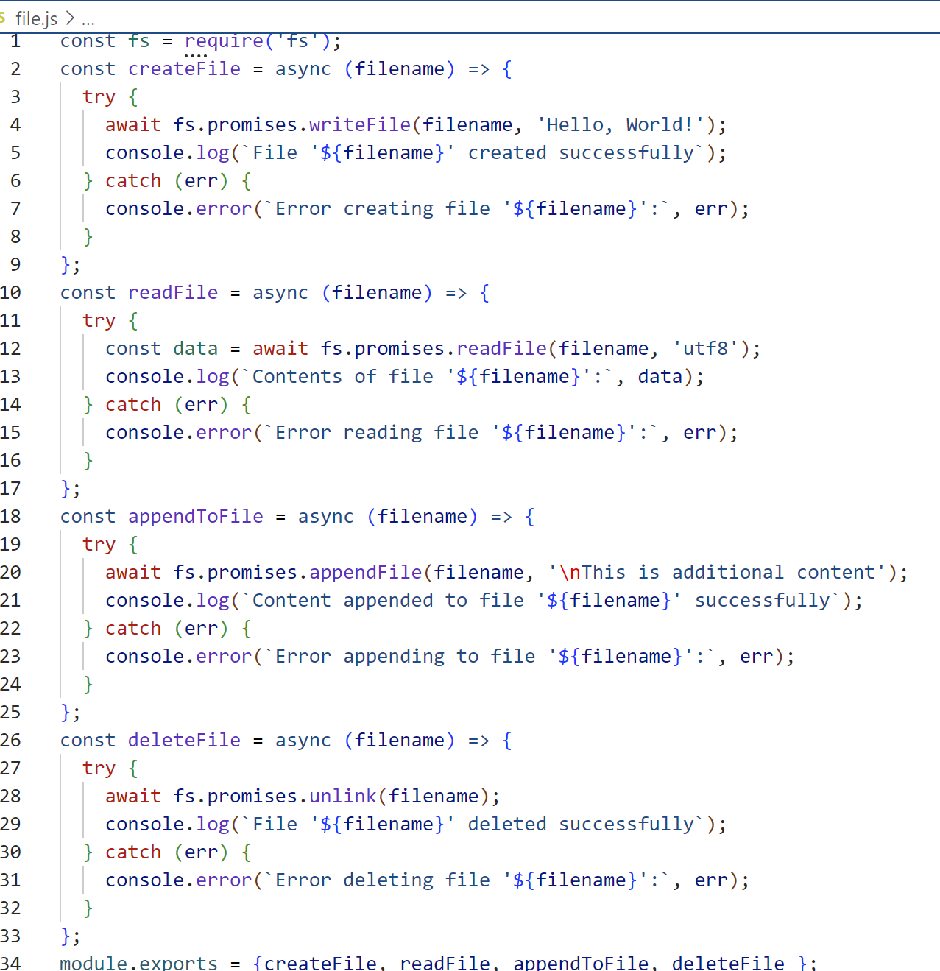

* In file index.js

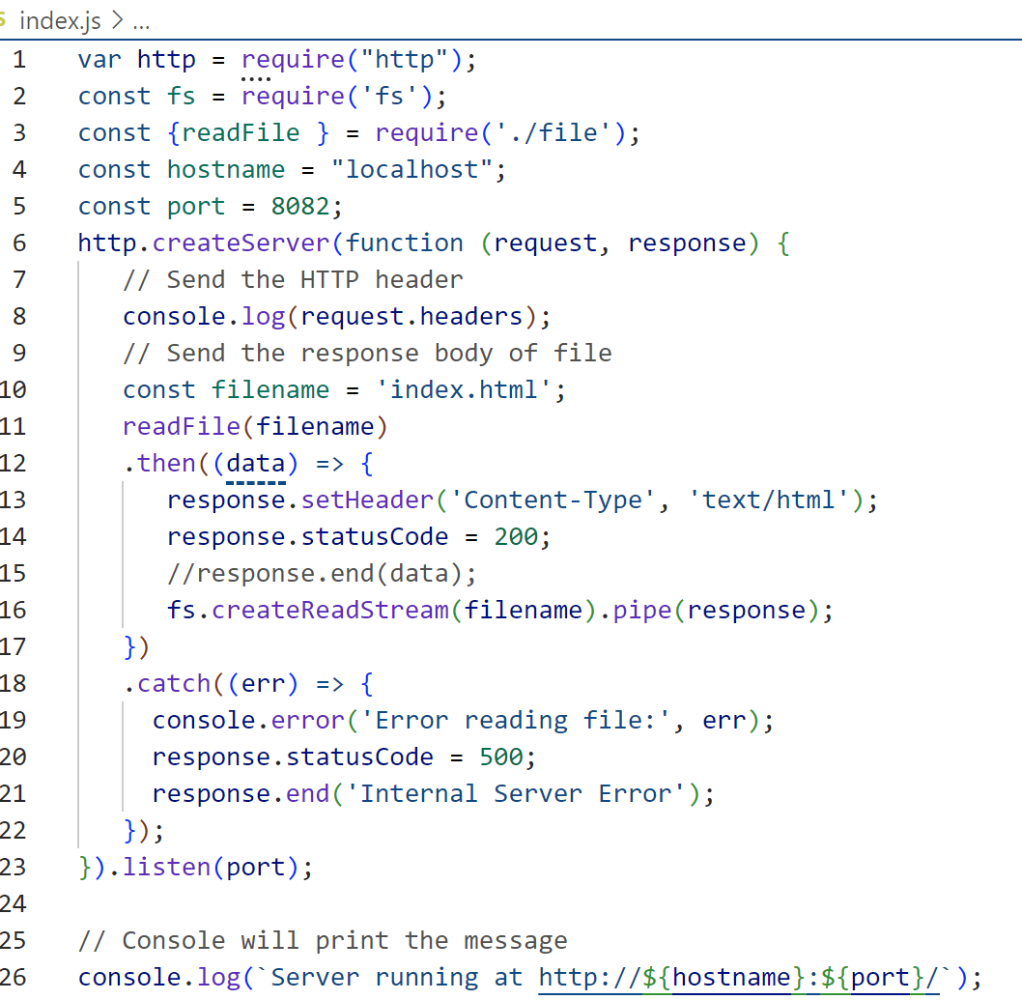

## Exercise 2: Demo about File System Interaction – File Path

* Create 2 files: index.html and about.html

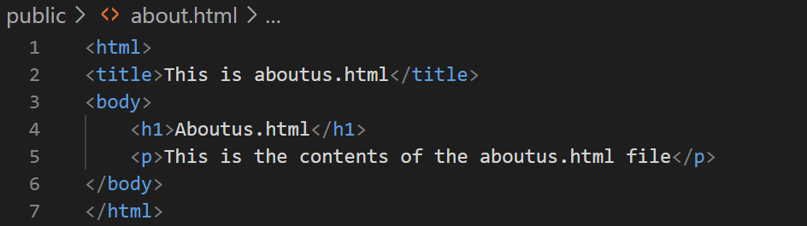

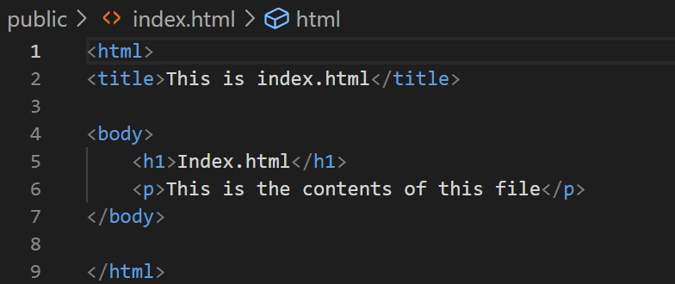

* Result

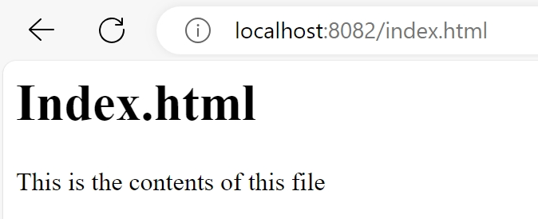

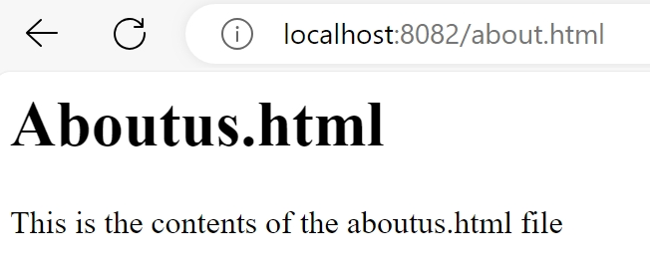

* Hint:

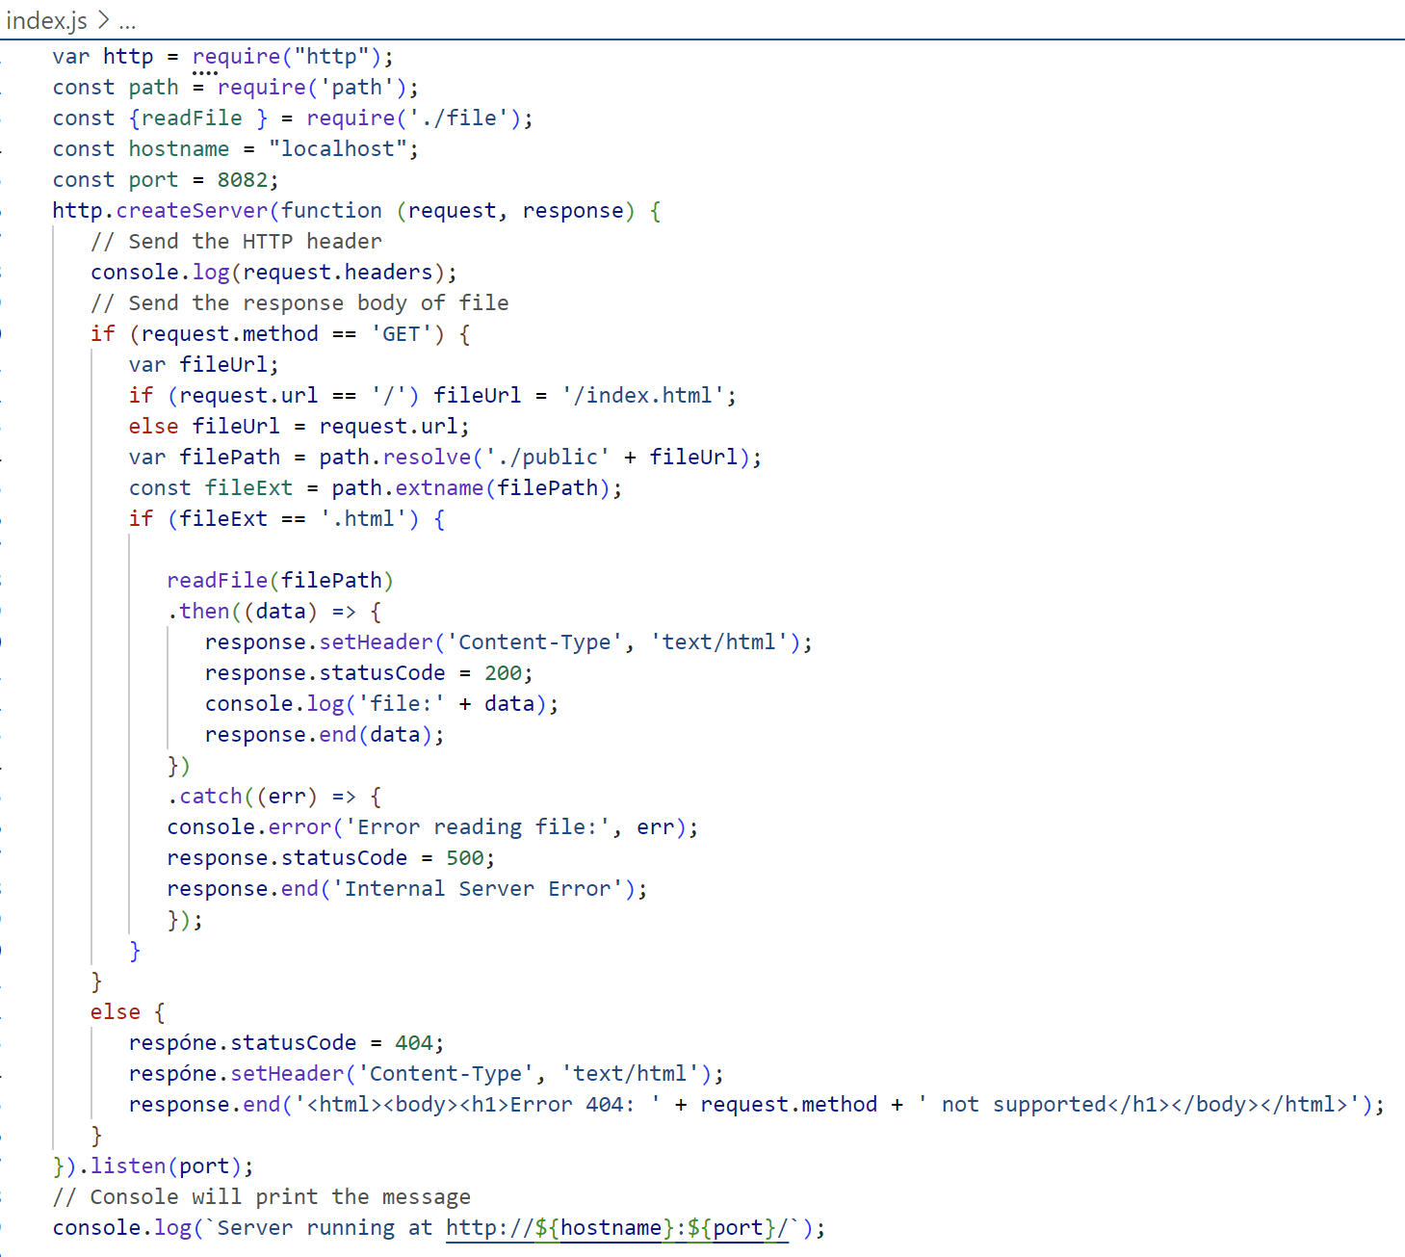

# Conclusion

This exercise aims to deepen your understanding of how to build a simple REST API using just Node.js and familiarize you with handling dynamic data on the server.